**Project Outcomes:**

**1.TaskOutcome:**

**🡺 start mysql in cloudera**

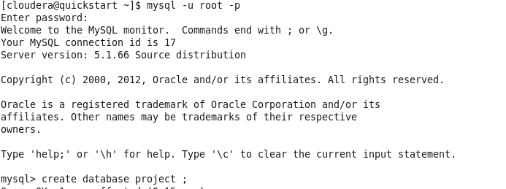

🡺**create a database** (database name is project)

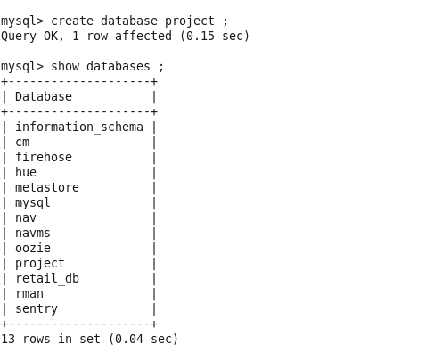

🡺**create a first table** (table name is click_data)

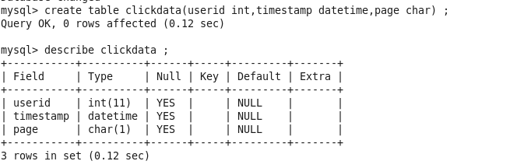

🡺**put data in first table using load command**(click_data table)

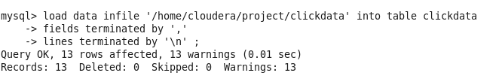

🡺**show the data first table using select statement**

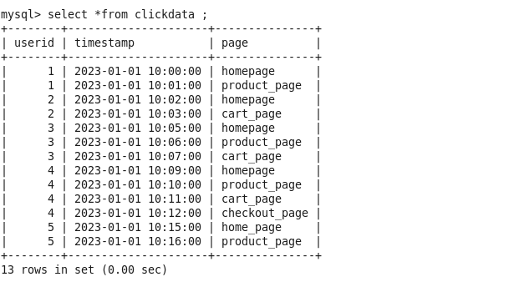

🡺**again doing same step in next table for customer_data and purchase_data:**

**For customer_data table:**

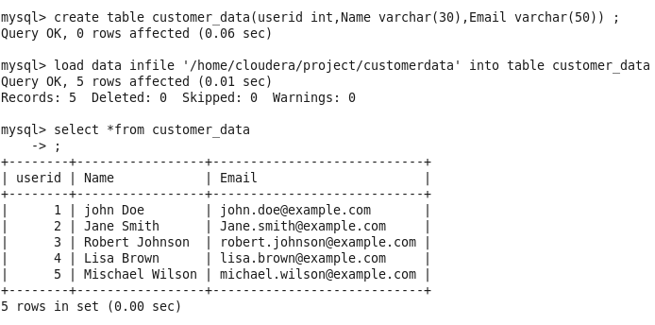

**For purchase_data table:**

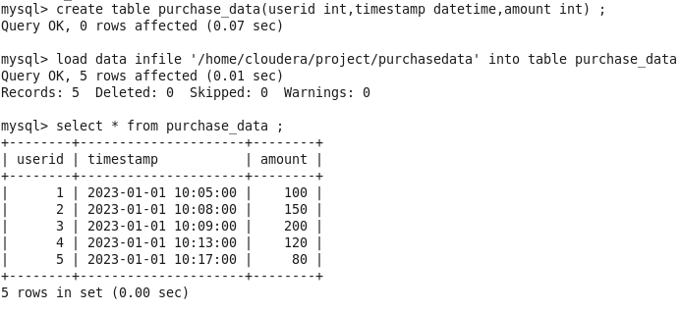

**2.TaskOutcomes:**

🡺**import data from mysql to hive using sqoop command:**

**🡺first create a database in hive and use this database and create a table:**

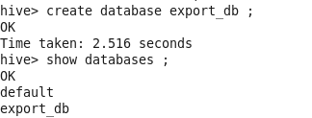

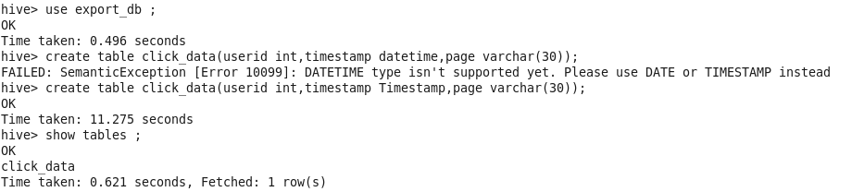

**🡺import mysql-table to hive using sqoop commands:**



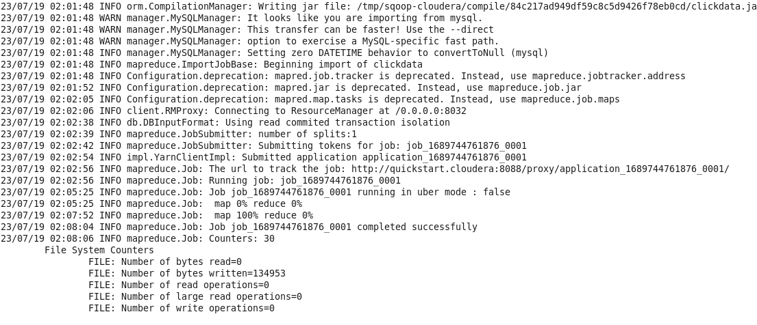

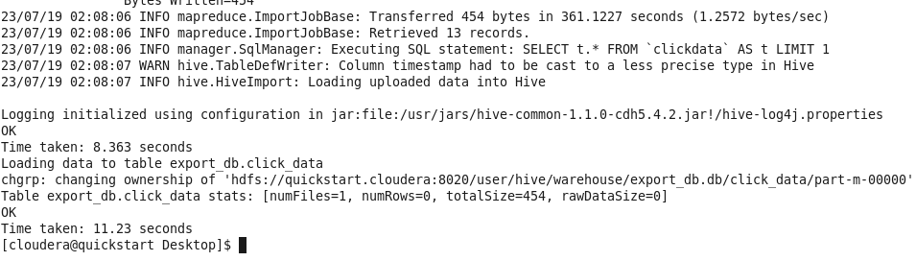

🡺**Go to hive check import status:**

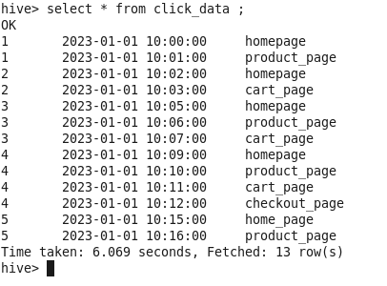

Success full import all rows are come in hive table this is first table import (clickdata) more two table are import mysql to hive

🡺**import customer_data table into hive:**



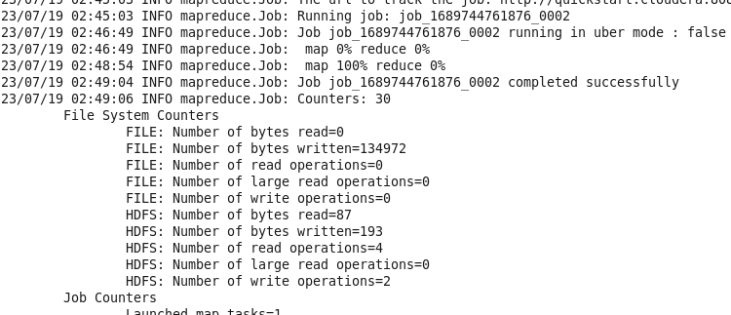

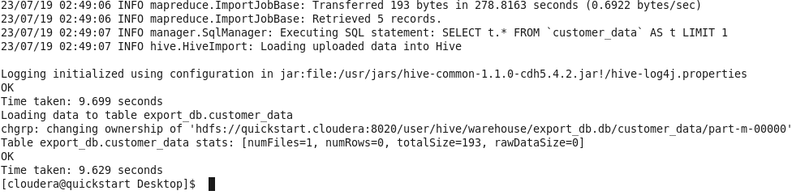

**See the results:**

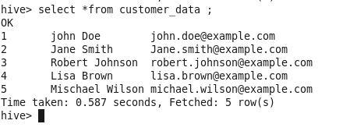

**🡺import purchase_data table into hive:**



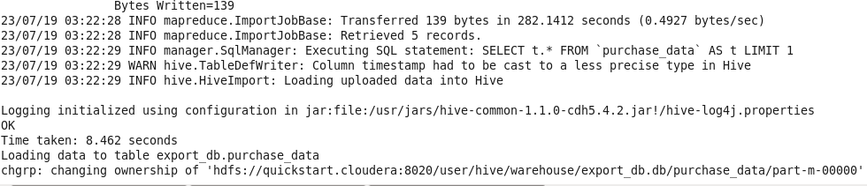

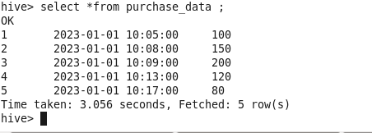

**Last table come in hive (purchase_data table).**

**3.TaskOutcomes:**

**1.Data Cleaning:**

🡺**Distinct element:**

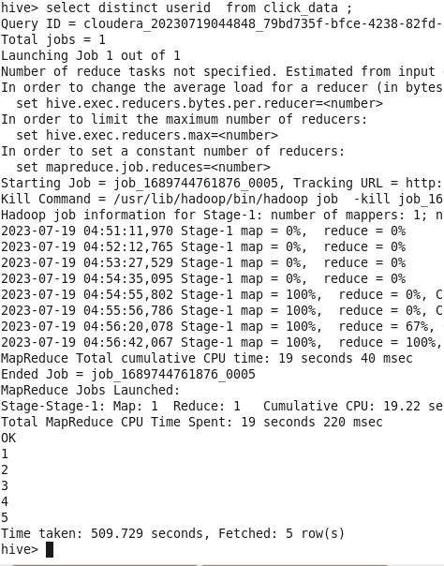

🡺**Data filter: use the where clause.**

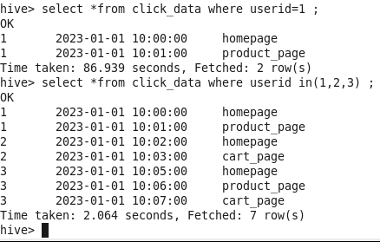

🡺**Data Aggregation :**

**Sum Function:**

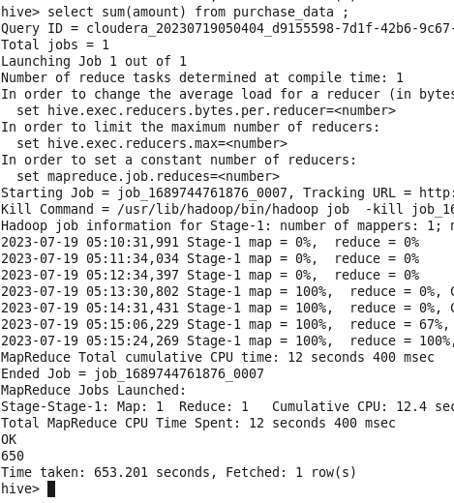

**Min Function:**

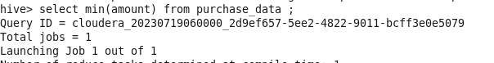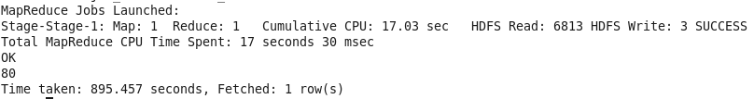

**Count:** 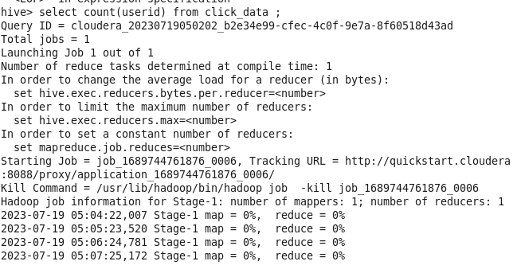

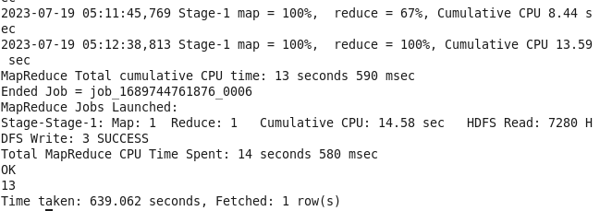

**Max Function:**

**C:\Users\HP\OneDrive\Desktop\boardinfinty-project\hadoop poto\30.PNG**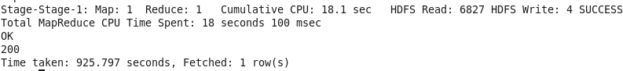

**3.Data Transformation:**

**Concat:**

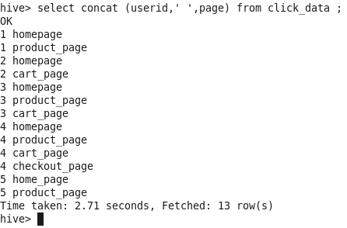

**String Manipulation:**

